Deerwalk Institute of Technology
Sifal, Kathmandu

Simulation and Modelling Practical 5

Submitted By: Submitted To:
Name: Sagar Giri Binod Sitaula
Roll No: 205
Section: A

Date:

Background Theory

Monte Carlo Method
Monte Carlo methods (or Monte Carlo experiments) are a broad class of computational algorithms that rely on repeated random sampling to obtain numerical results. They are often used in physical and mathematical problems and are most useful when it is difficult or impossible to use other mathematical methods. Monte Carlo methods are mainly used in three distinct problem classes: optimization, numerical integration, and generation of draws from a probability distribution.

Use of Monte Carlo Method to find the value of PI
Algorithm:
1. Input the no. of points to be taken (N) i.e. no. of experiments.
2. Initialixaze the value of n=0
3. For i=0 to N:
- generate random numbers of x and y
- test for the point if
end for
4. Calculate Pi =
5. Print the result. And compare with the exact one.

Program Code:
#include <stdio.h>
#include <stdlib.h>
#define f(x,y) x*x+y*y-1
#define MAX_RAND 100
int main()
{
int N, n =0, i;
double pi_calc,randx, randy;
printf("Enter the no. of points to be taken? \n");
scanf("%d",&N);
for(i=0;i<N;i++){
randx = (double)(rand()%(100))/(double) MAX_RAND;
randy = (double)(rand()%(100))/(double) MAX_RAND;
if(f(randx,randy)<=0){
n++;
}
}
pi_calc = ((double) n/N)*4;
printf("%lf",pi_calc);
return 0;
}

Output:
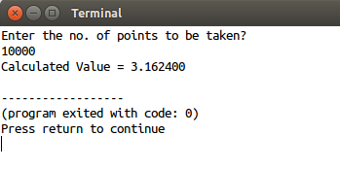

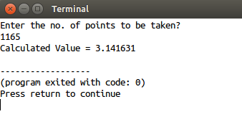

Conclusion:

Hence using Monte Carlo simulation method and its algorithm, the value of Pi was calculated.
Use of Monte Carlo Method to find the value of square root of 3
Algorithm:
1. Input the no. of points to be taken (N) i.e. no. of experiments.
2. Initialize the value of n=0
3. For i=0 to N:
- generate random numbers of x that lies between 1 and 2
- test for the point if
end for
4. Calculate root_3 =
5. Print the result. And compare with the exact one.

Program Code:
#include <stdio.h>
#include <stdlib.h>
#define f(x) x*x
int main()
{
int N, n =0, i;
double root_3,randx;
printf("Enter the no. of points to be taken? \n");
scanf("%d",&N);
for(i=0;i<N;i++){
randx = (double)(1)/RAND_MAX*rand()+1;
if(f(randx)<=3){
n += 1;
}
}
root_3 = 1+((double)n/N);
printf("%lf",root_3);
return 0;
}

Output:
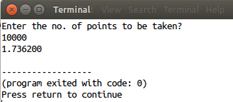
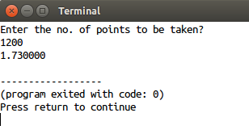

Conclusion:
Hence using Monte Carlo simulation method and its algorithm, the value of square root of 3 was calculated.

